ư

USER GUIDE



Table of Contents

**1.** **Jira Accenture account (abc@wisewires.com)** 1

**2.** **Samsung Jira account (a.b.c)** 12

**3.** **Team Up (abc@wisewires.com)** 15

## **Jira Accenture account (**[**abc@wisewires.com**](mailto:abc@wisewires.com)**)**

Check Outlook to find an email from Bermodes, Sandra M. T. [sandra.m.t.bermodes@accenture.com](mailto:sandra.m.t.bermodes@accenture.com) or Samsung.PMO.Support <[Samsung.PMO.Support@accenture.com](mailto:Samsung.PMO.Support@accenture.com)> as below

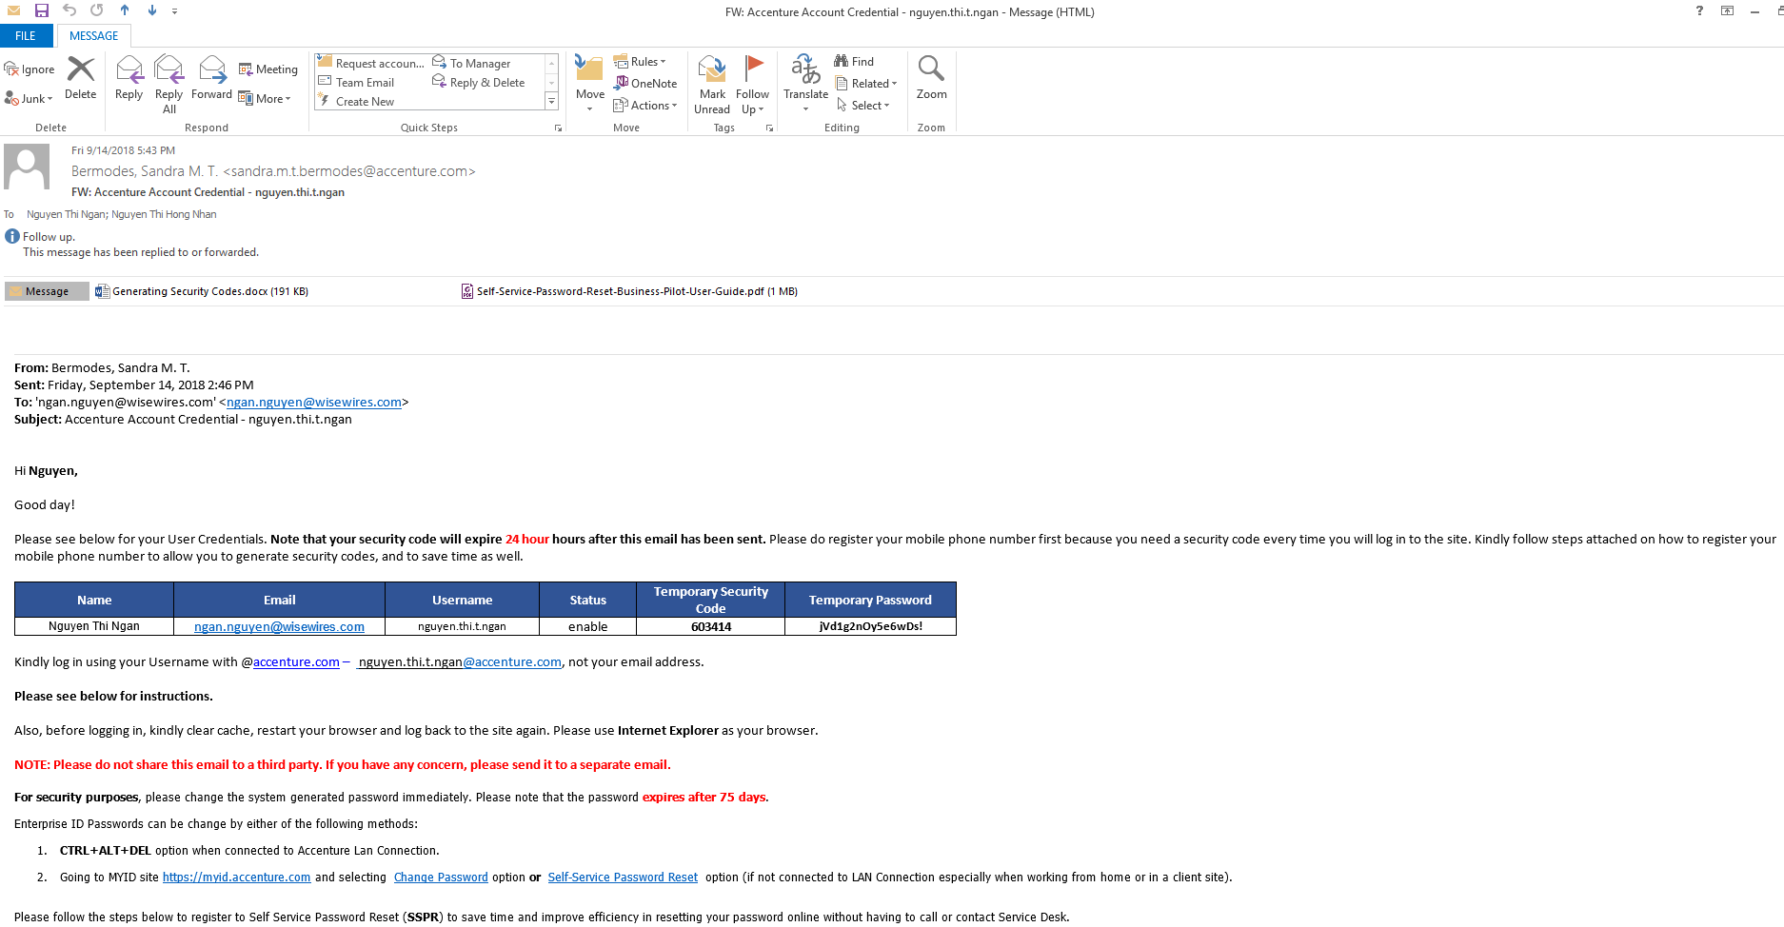

Read your email carefully. **Note that your security code will be expired in the next 24 hour after the credential email has been sent**. Before logging in, kindly clear cache, restart your browser and log back to the site again.

Please use **Internet Explorer** as your browser.

Enter <https://myid.accenture.com/> and select Self-Services Password Registration

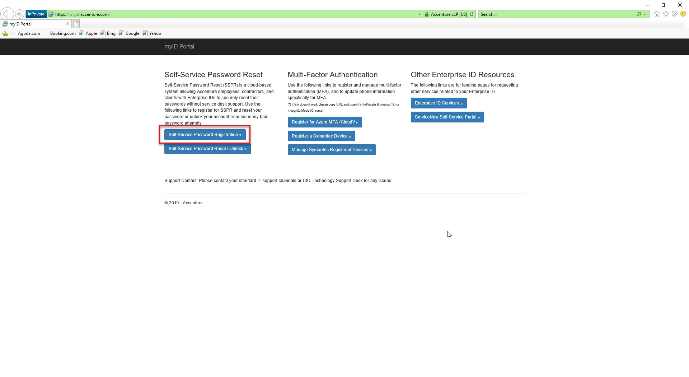

Enter Account Password

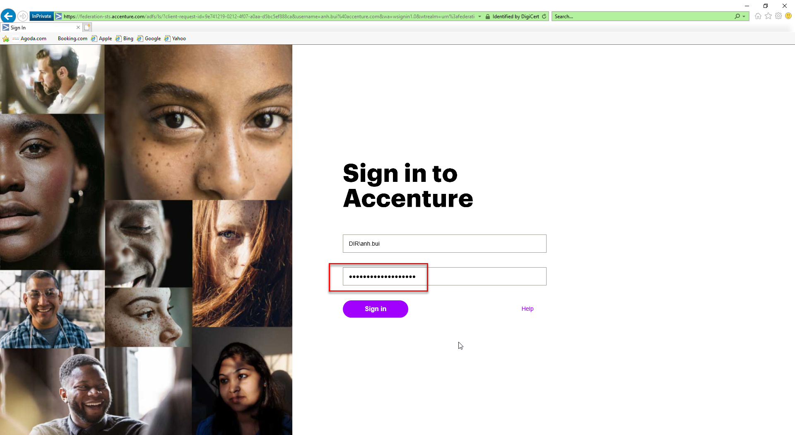

Input the Security Code from the mail and click Remember this private Device and click Continue.

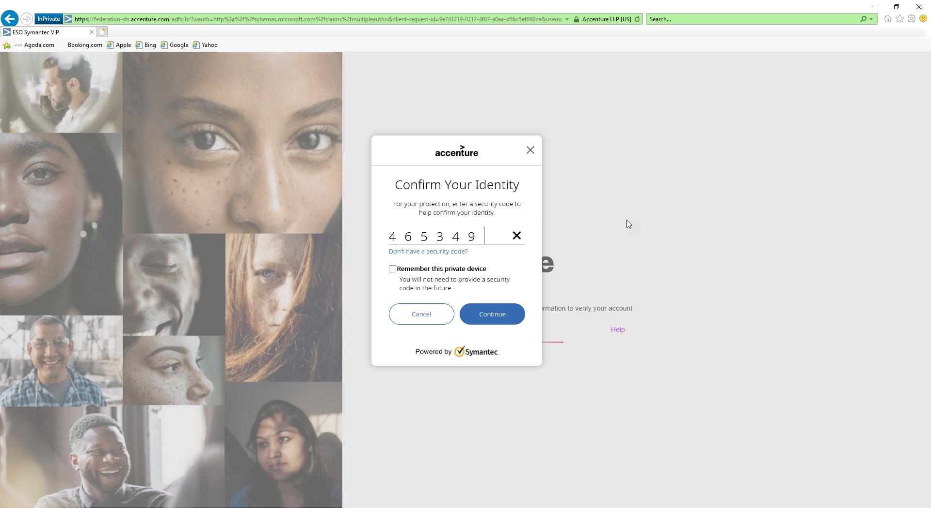

You will be redirected to mysignins website, choose I want to use a different authenticator app and click Next. Note: Make sure that you have Google Authenticator App installed in your mobile phone.

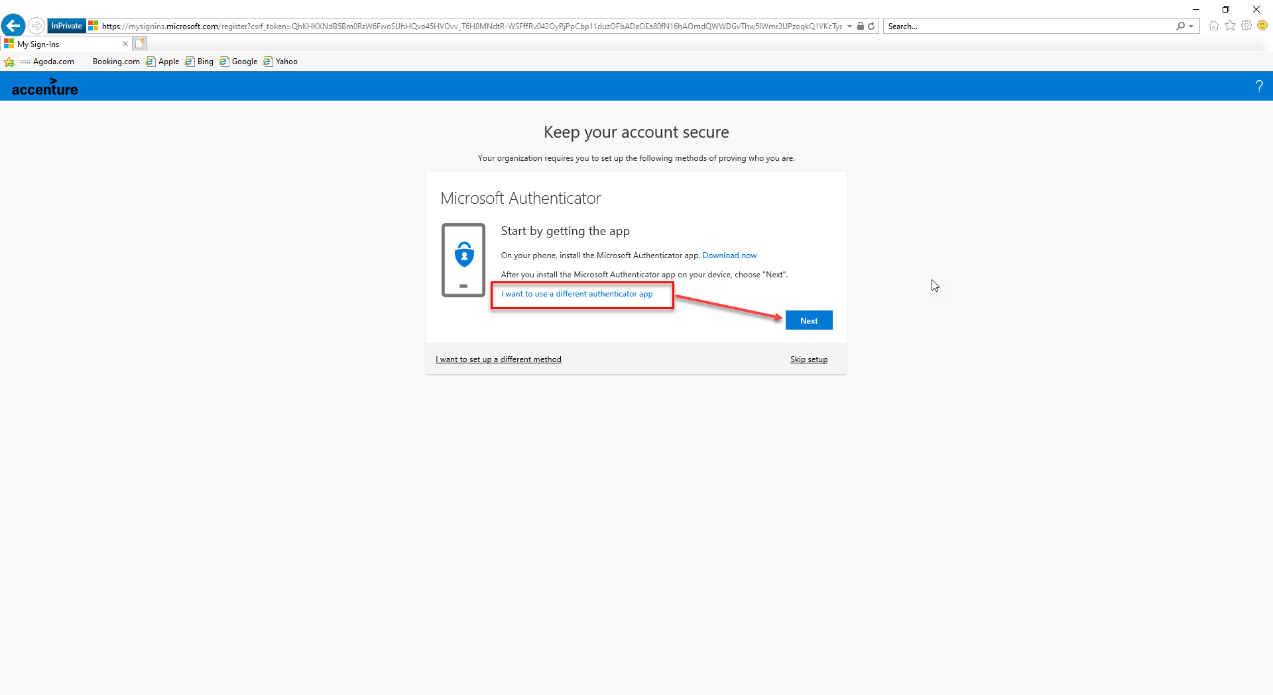

Click Next

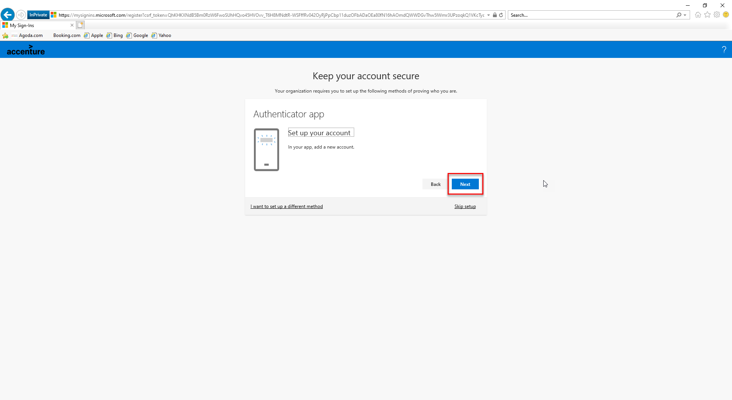

Open Google Authenticator App and scan the QR code and click Next.

Note: please **save the QR code** for the using of next time.

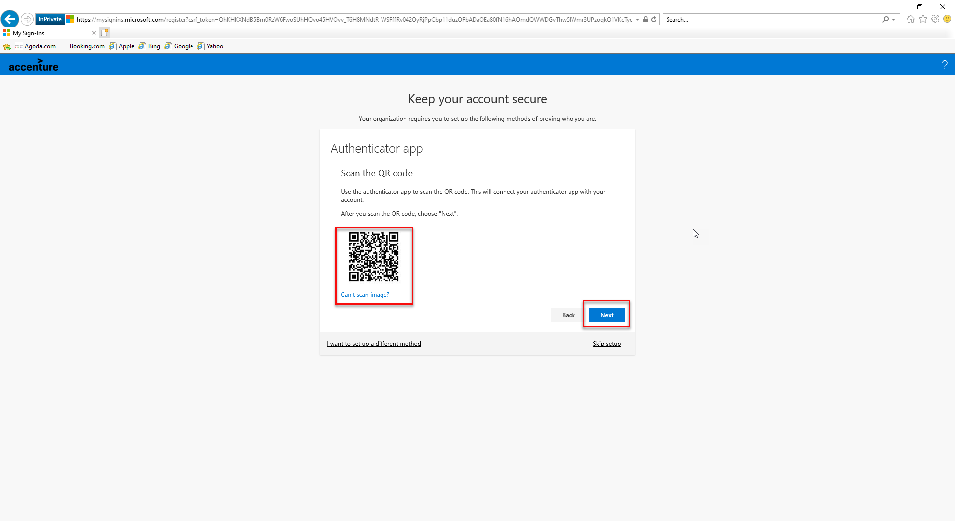

Enter the Code from your Google Authenticator App and click Next

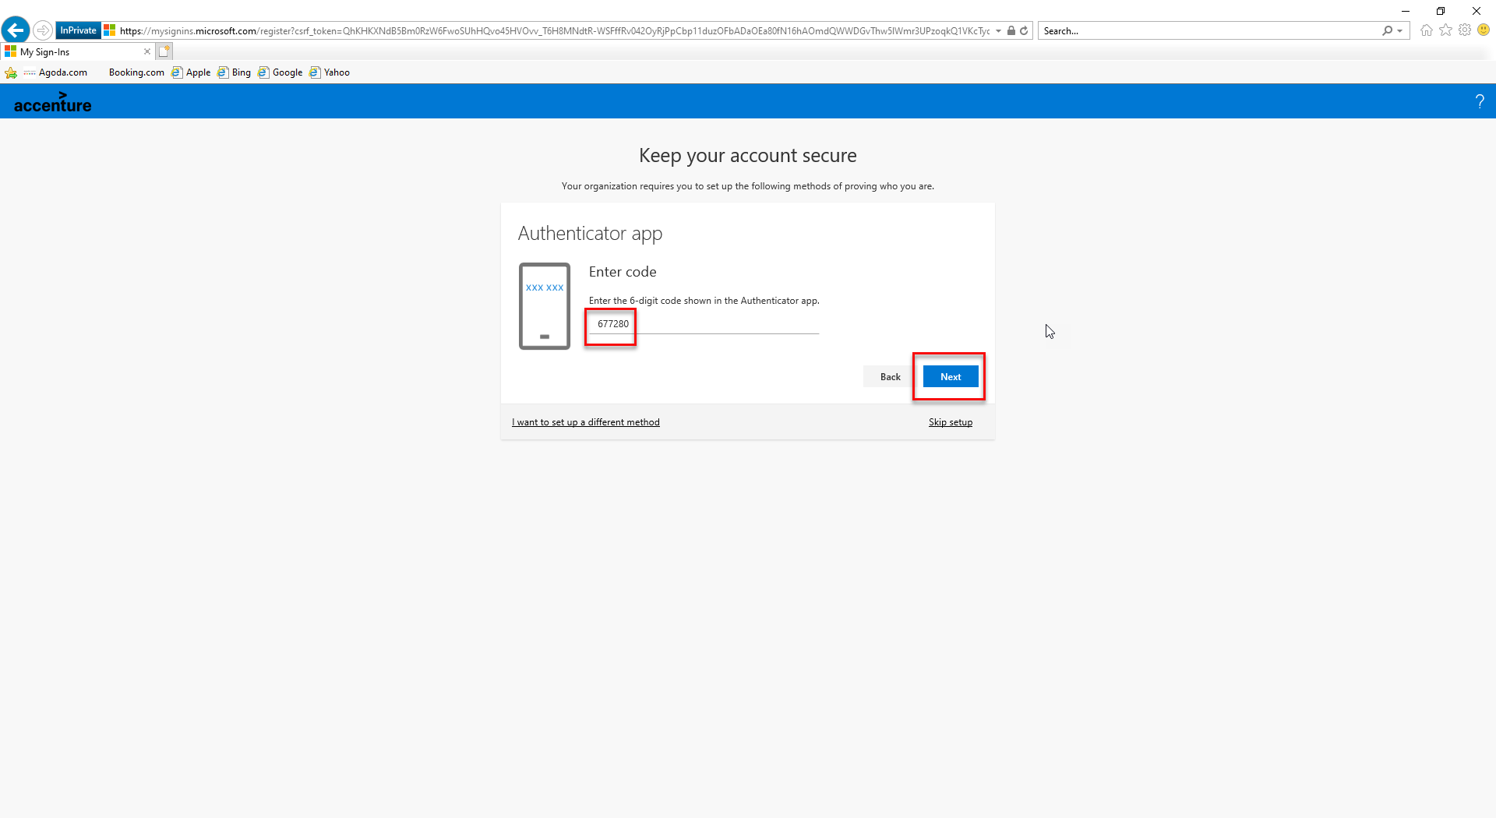

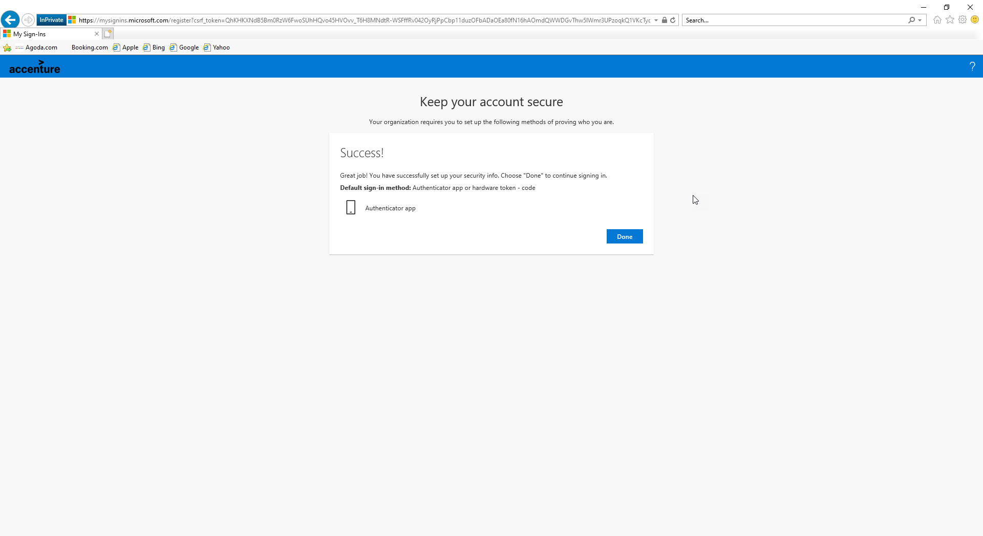

You will then be redirected to Security Info page: <https://mysignins.microsoft.com/security-info>

Click on Add Method and select Phone from the dropdown list.

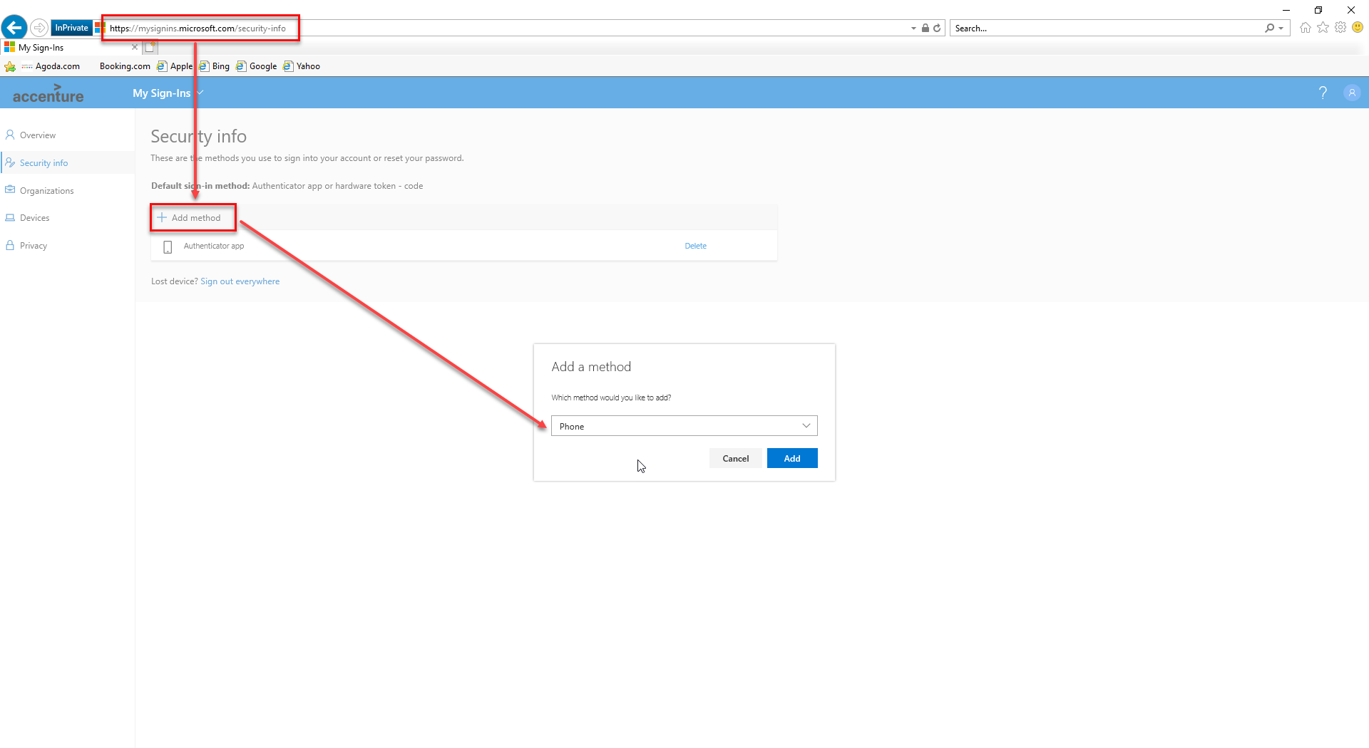

Enter your mobile number to the field, choose the Text me a code method and click Next.

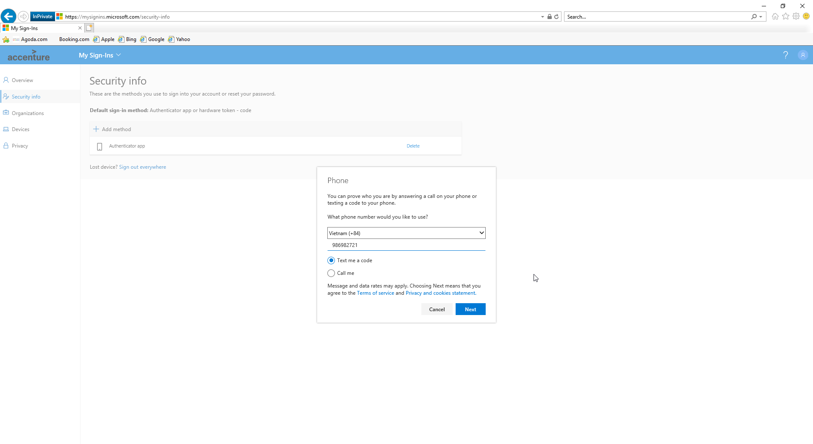

Open your phone to take the security code and fill it in the box.

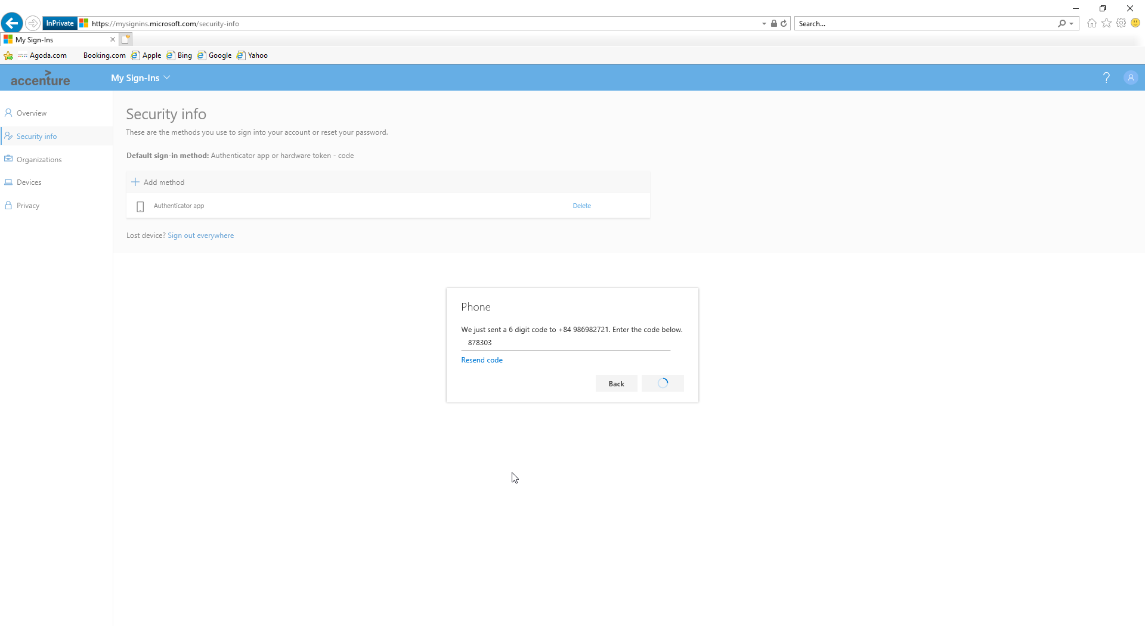

Completion screen

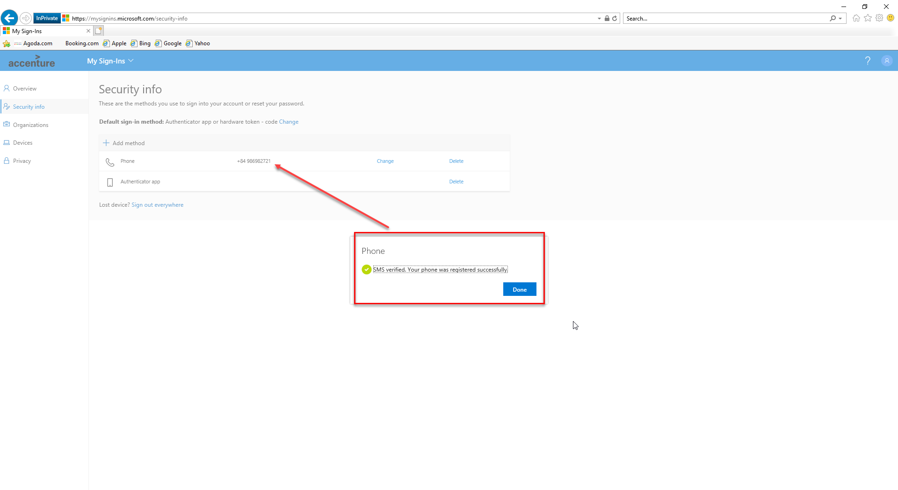

Now, you have to change your password, in the same browser, enter one of the below links <https://account.activedirectory.windowsazure.com/ChangePassword.aspx>

https://directory.accenture.com/ChangePassword/

and input Old and New passwords and click Submit.

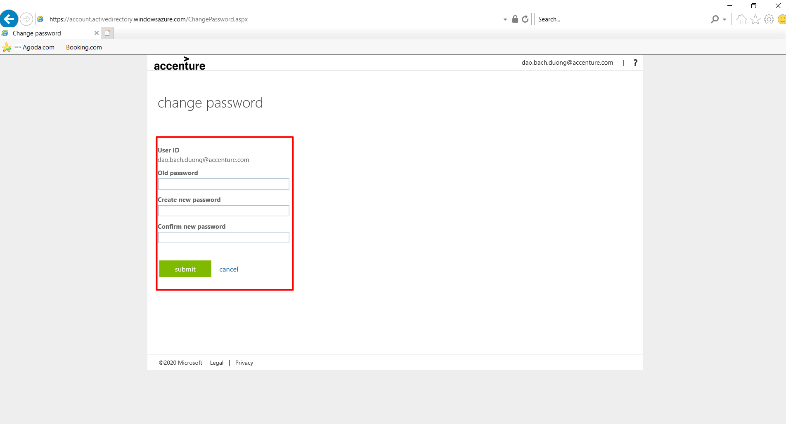NOTE: **For security purposes**, password **expires after 75 days**, please change the password before deadline.

When page redirects to the Profile page, you have changed your password successfully.

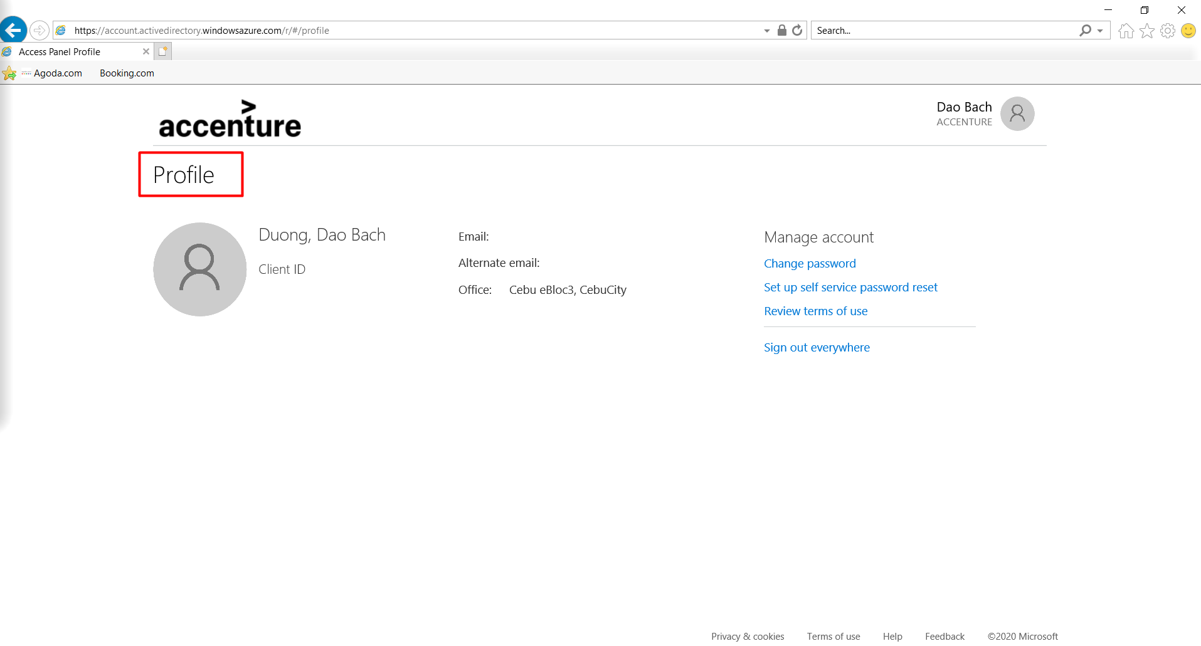

Now check your authority on the following page

1. Wiki – enter <https://alm.accenture.com/wiki/display/STK/13.+SME+-+Requirements+-+Localisation+Configurations>

Input your user name and password > click on Don’t have a security code > click Send.

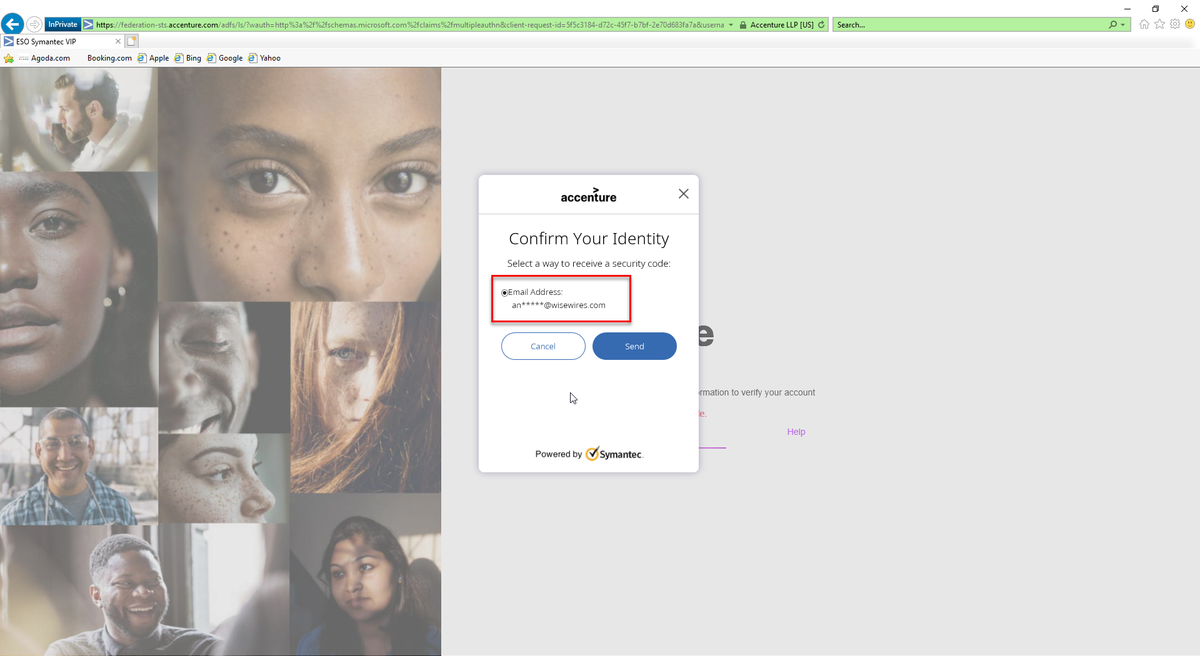

Check if this page displays well and you are able to download the files > Pass!

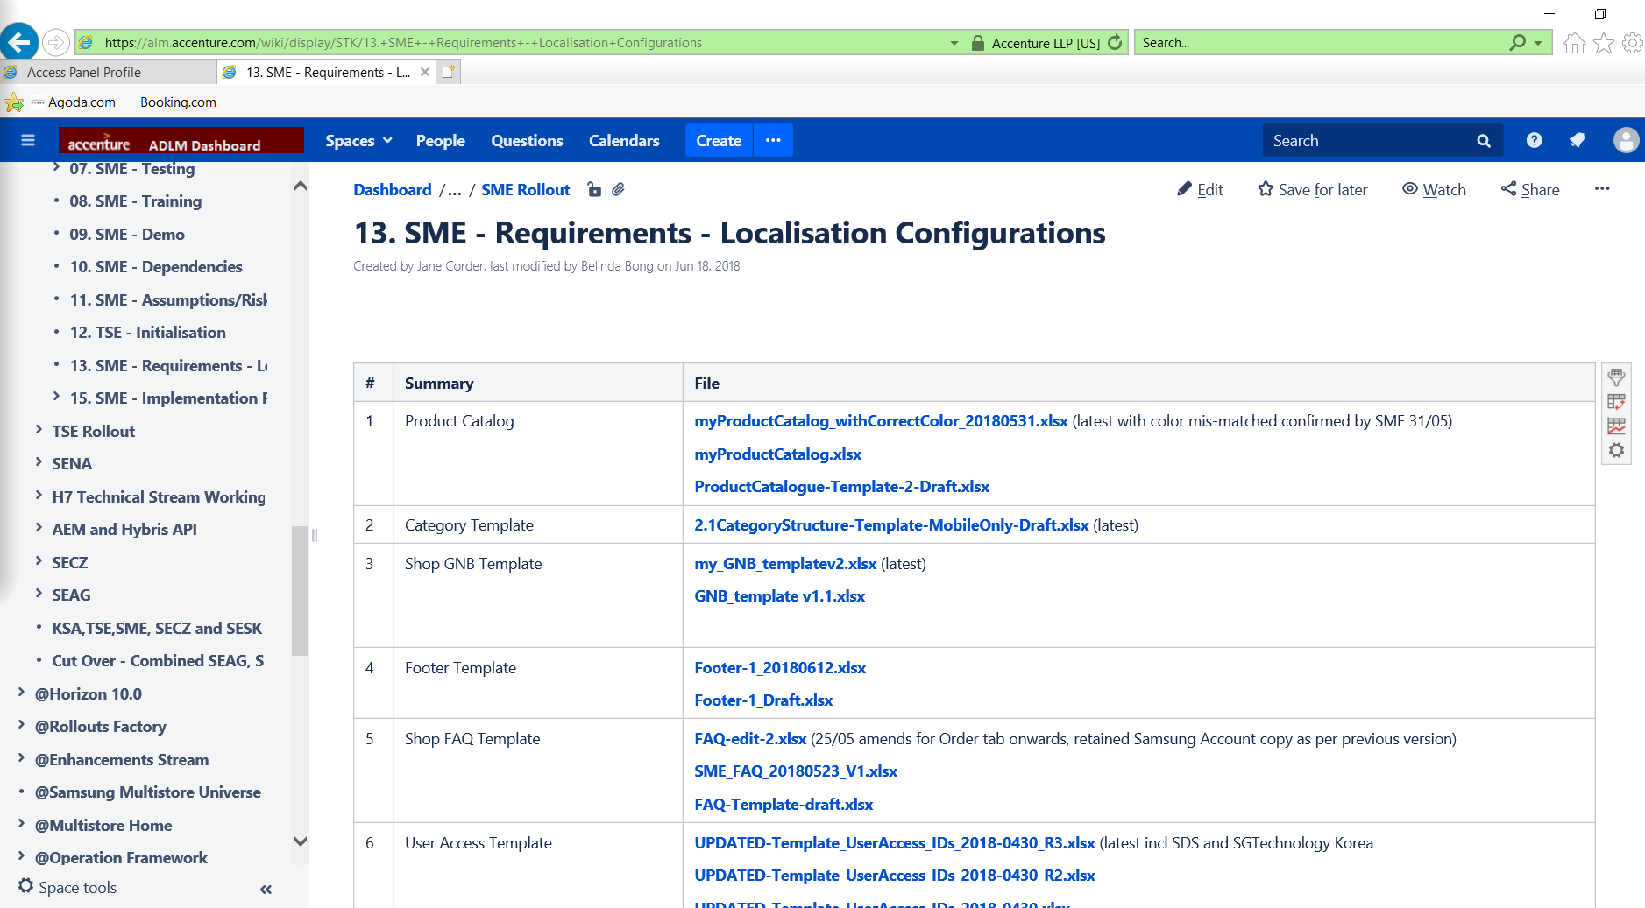

**Reset password**

Enter <https://myid.accenture.com/> > click on Self-Service Password Reset / Unlock

Input your username and type the code

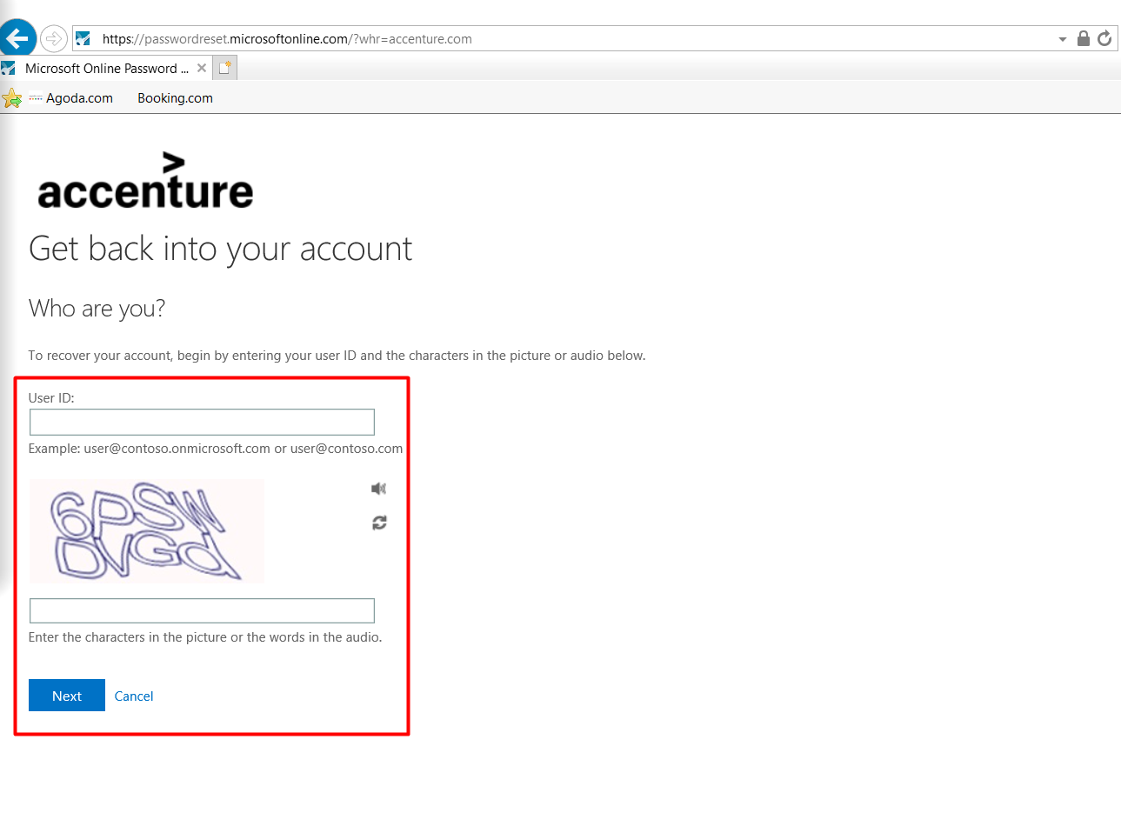

Select I forgot my password and click Next

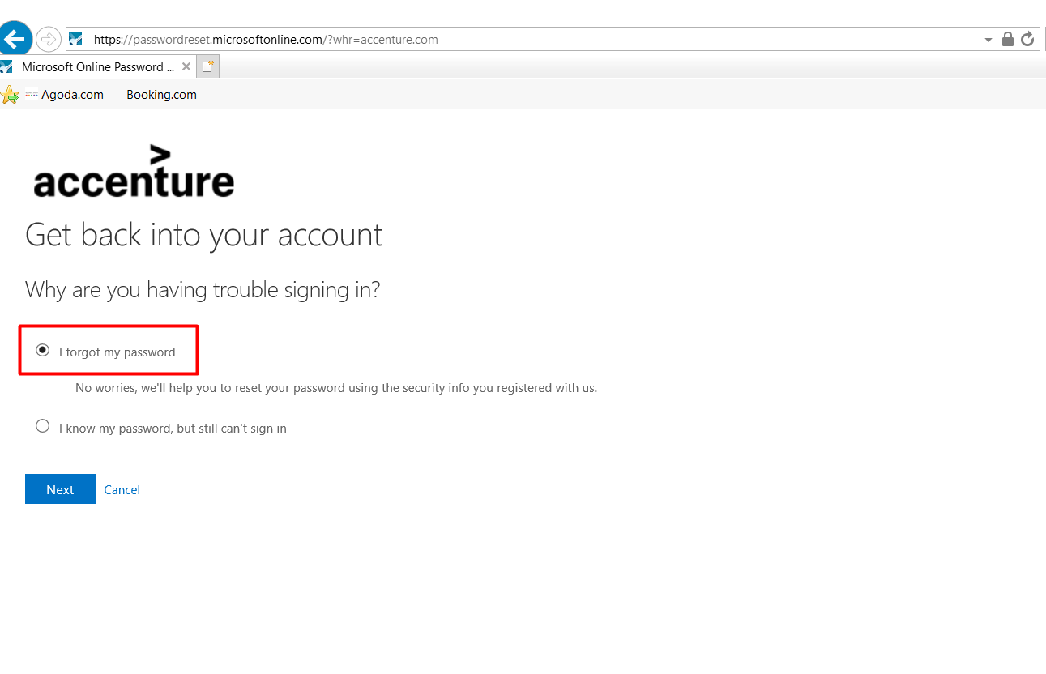

Select Text my mobile phone and input your mobile number and click Text

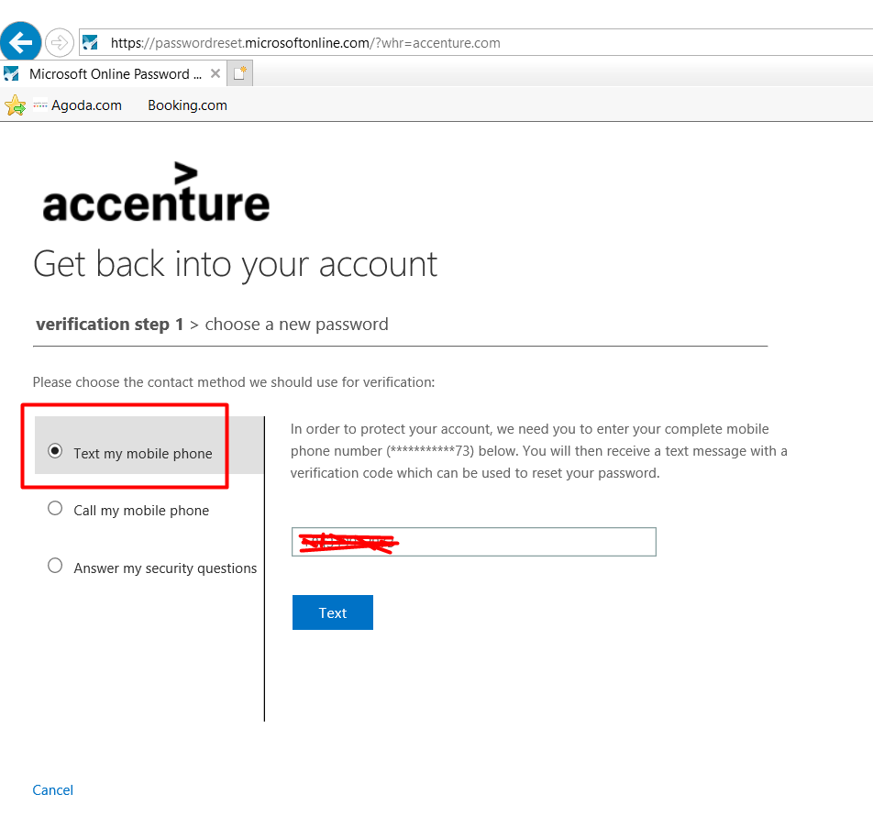

Input Verification Code and click Next

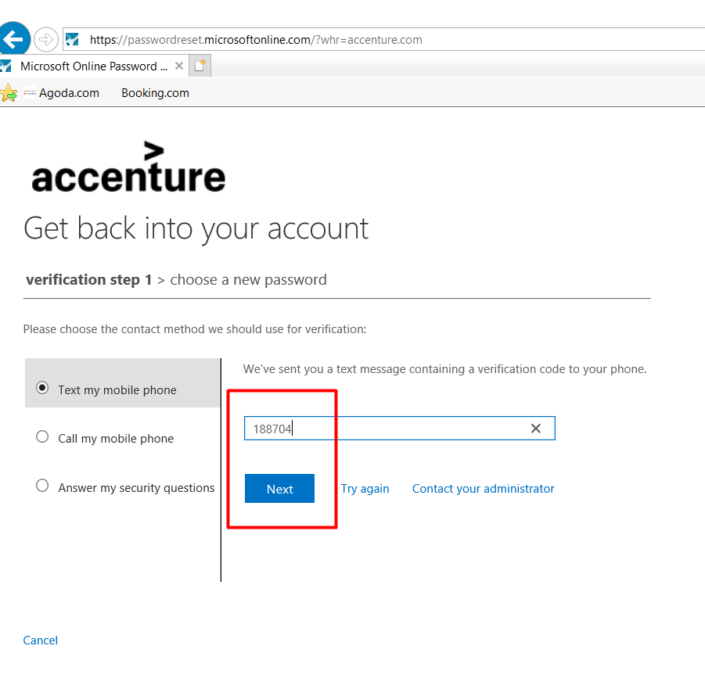

Now enter your new password and click Finish

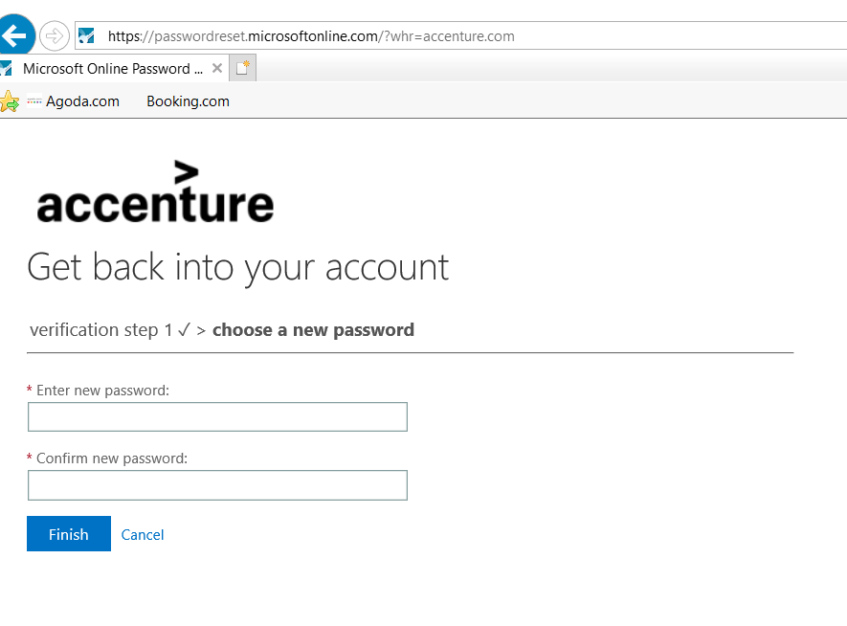

## **Samsung Jira account (a.b.c)**

* **Step 1**: Check Outlook to find an email from [eshop.jira@samsung.com](mailto:eshop.jira@samsung.com) as below

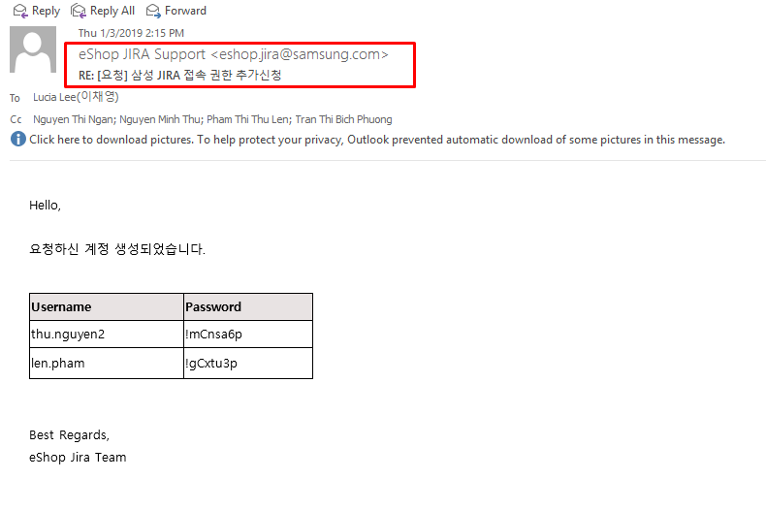

* **Step 2**: Download **Google Authenticator** app to your smartphone. Using this app for security purpose.

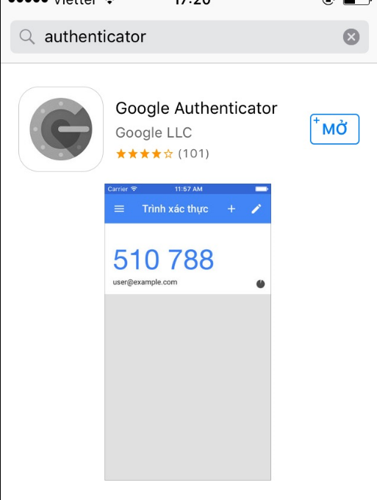

* **Step 3**: Open link: <https://jira.shop.samsung.com:8443/secure/Dashboard.jspa> and input **User name** and **password** which has received from email in order to login Samsung Jira page. It will display a **BARCODE** for the first time login.
* **Step 4**: Screenshot a barcode in Samsung Jira page and save it in your laptop in case of forgetting the password, etc. We can use this barcode to login again. (High important)
* **Step 5**: Open Authenticator app and choose “**Scan barcode**”. Scan a barcode which is displayed in Samsung Jira page.

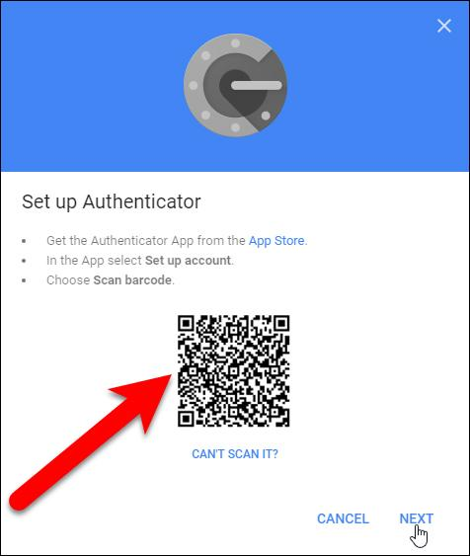

After scanning barcode is successfully, app will show as below:

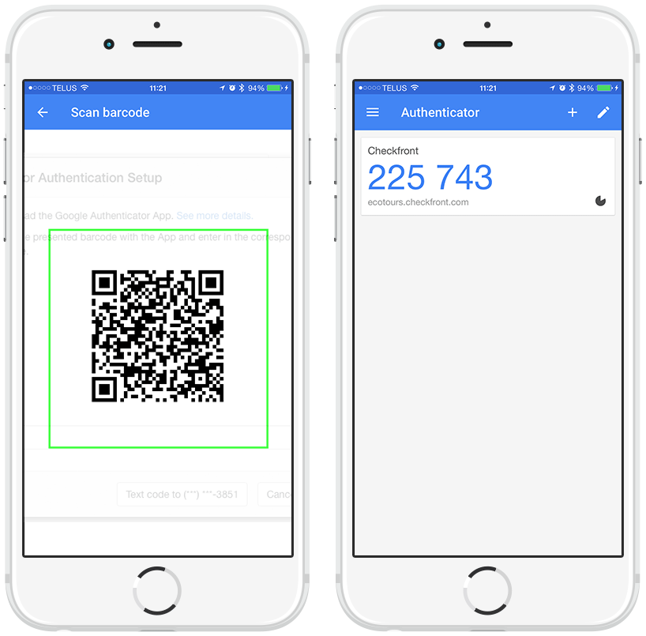

* **Step 6**: After logging in successfully, click on Account icon and choose “**Profile**” to change password.

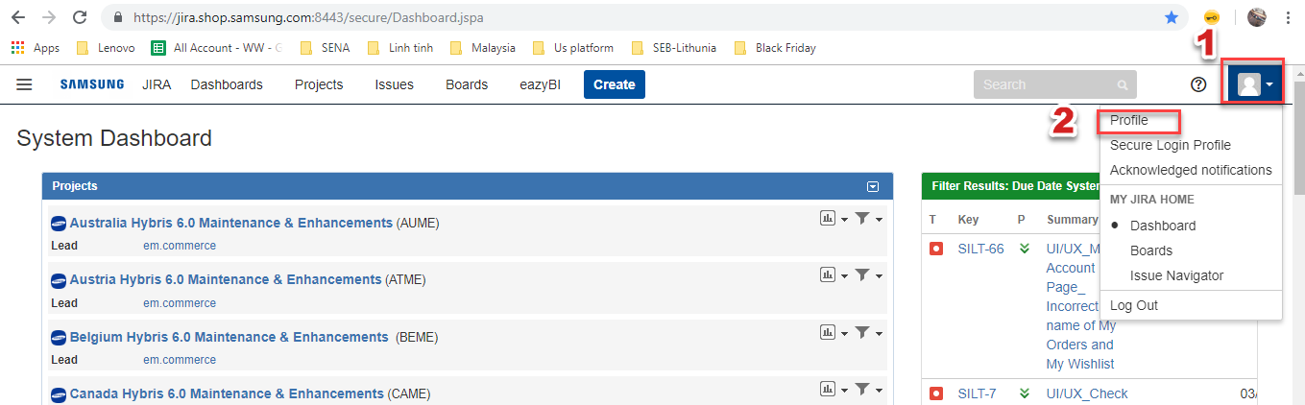

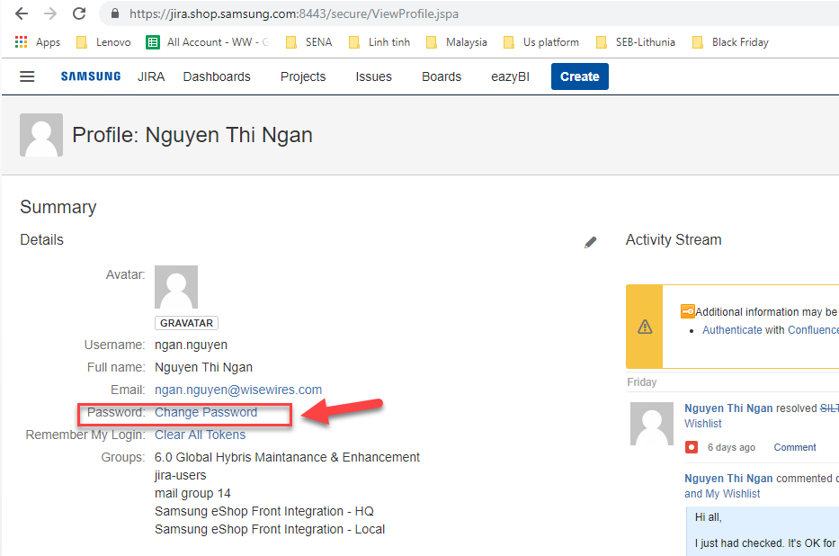

NOTE: **For security purposes**, password **expires after 75 days**, please change the password before deadline.

## **Team Up (**[**abc@wisewires.com**](mailto:abc@wisewires.com)**)**

* **Step 1**: Download Teamup official at <https://tmup.com/main/download> and install it.

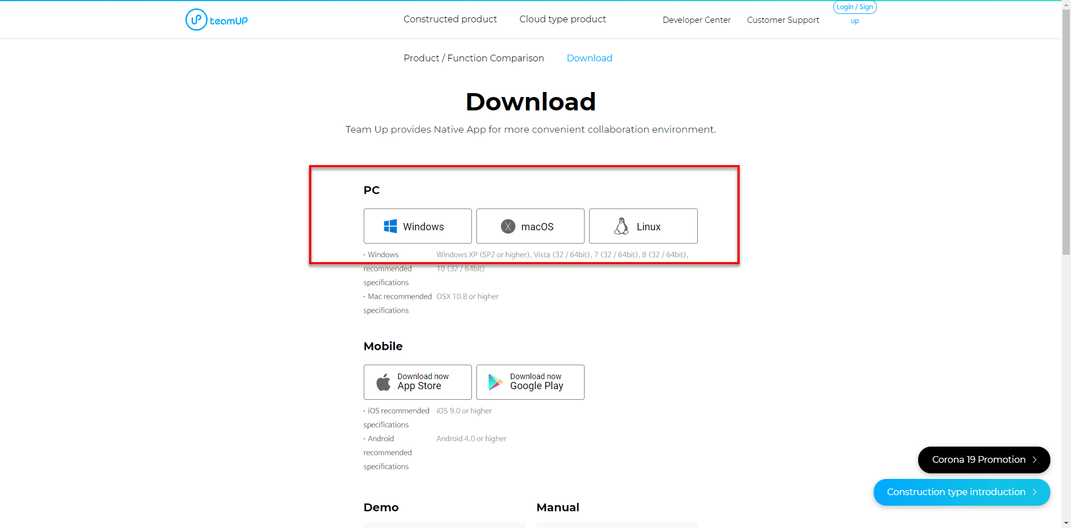

* **Step 2**: In TeamUP homepage <https://tmup.com/>, click on Signup

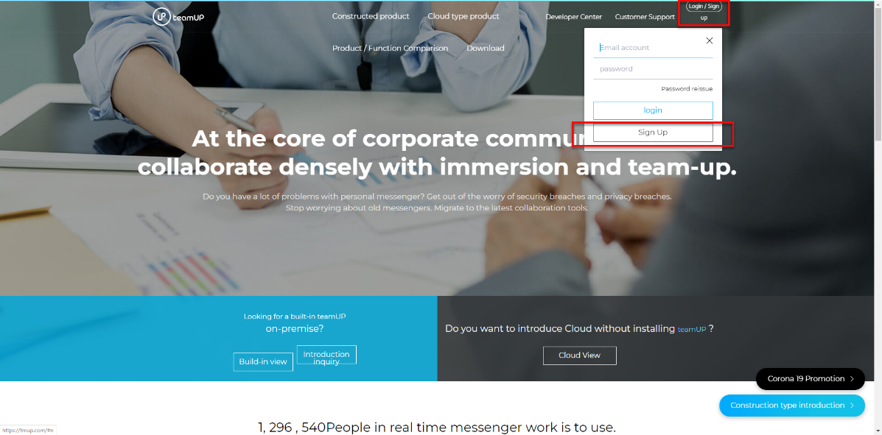

* **Step 3**: Enter your WISEWIRES email

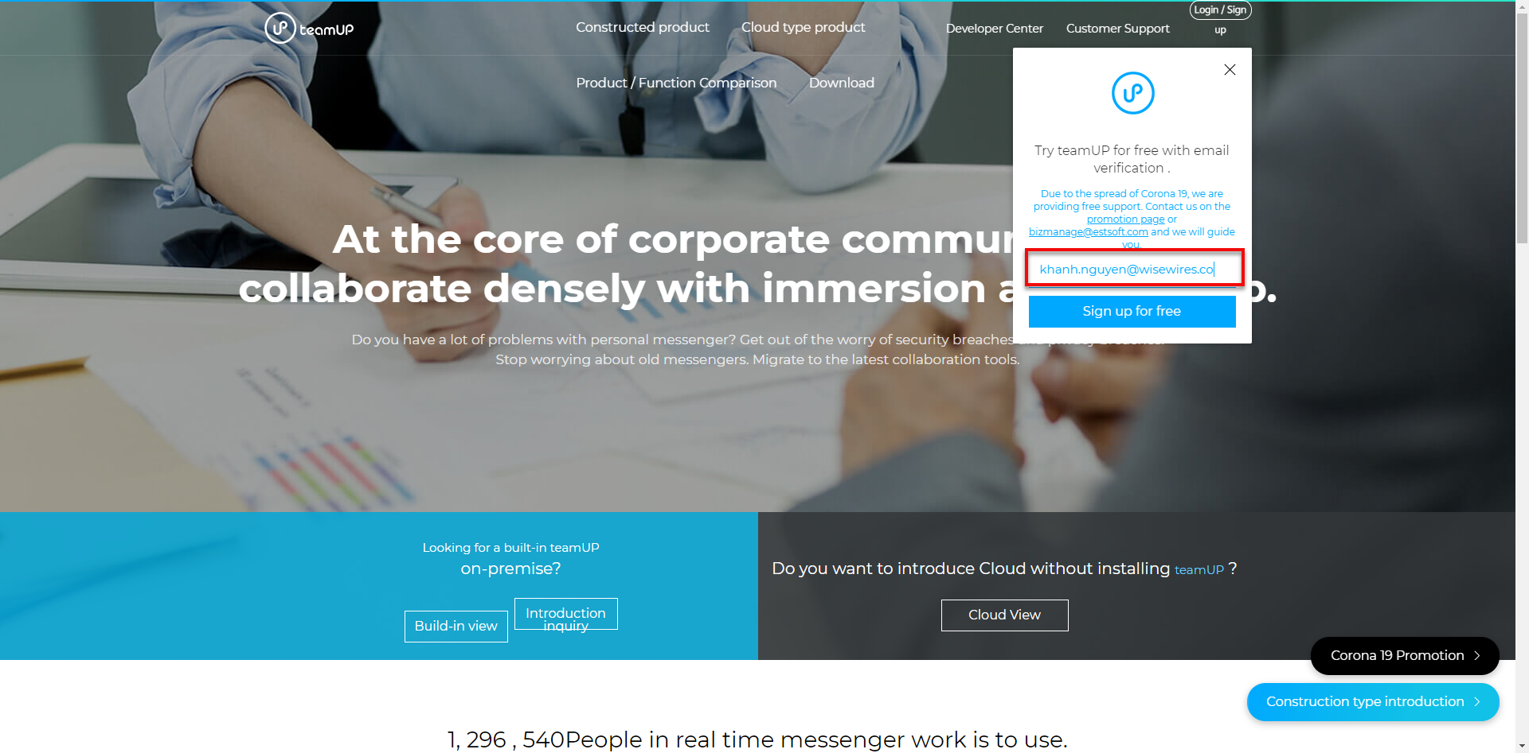

* **Step 4**: Check an email which has just been sent in Outlook -> Click “**Sign up**” button.

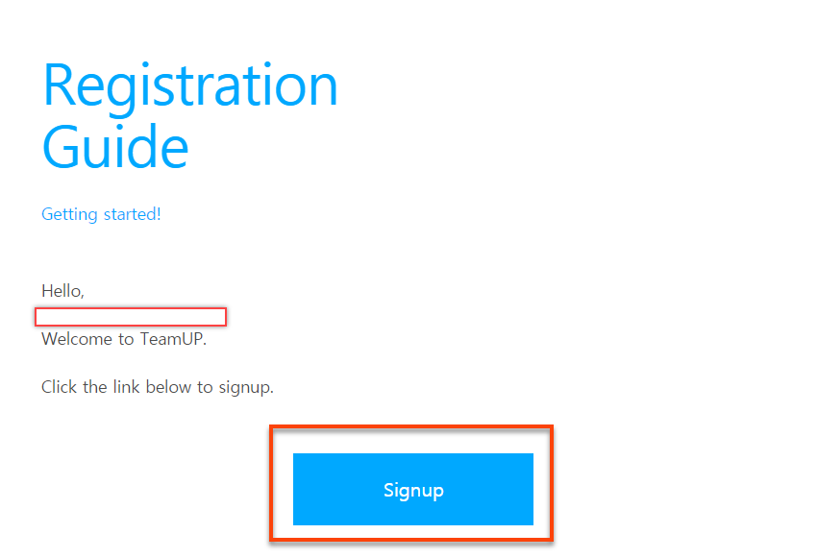

* **Step 5**: Input all required fields, then accept Terms and Conditions and click “**Register**”.

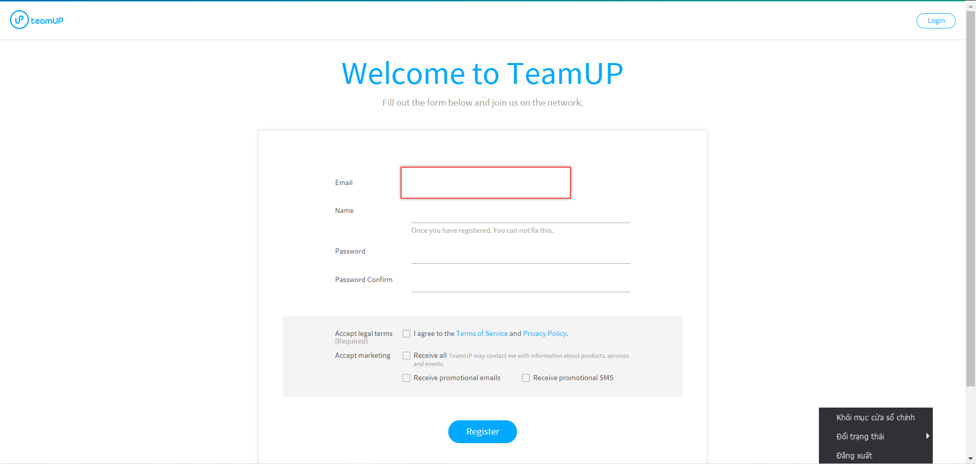

* **Step 6**: Display a page to announce that you registered an account successfully.

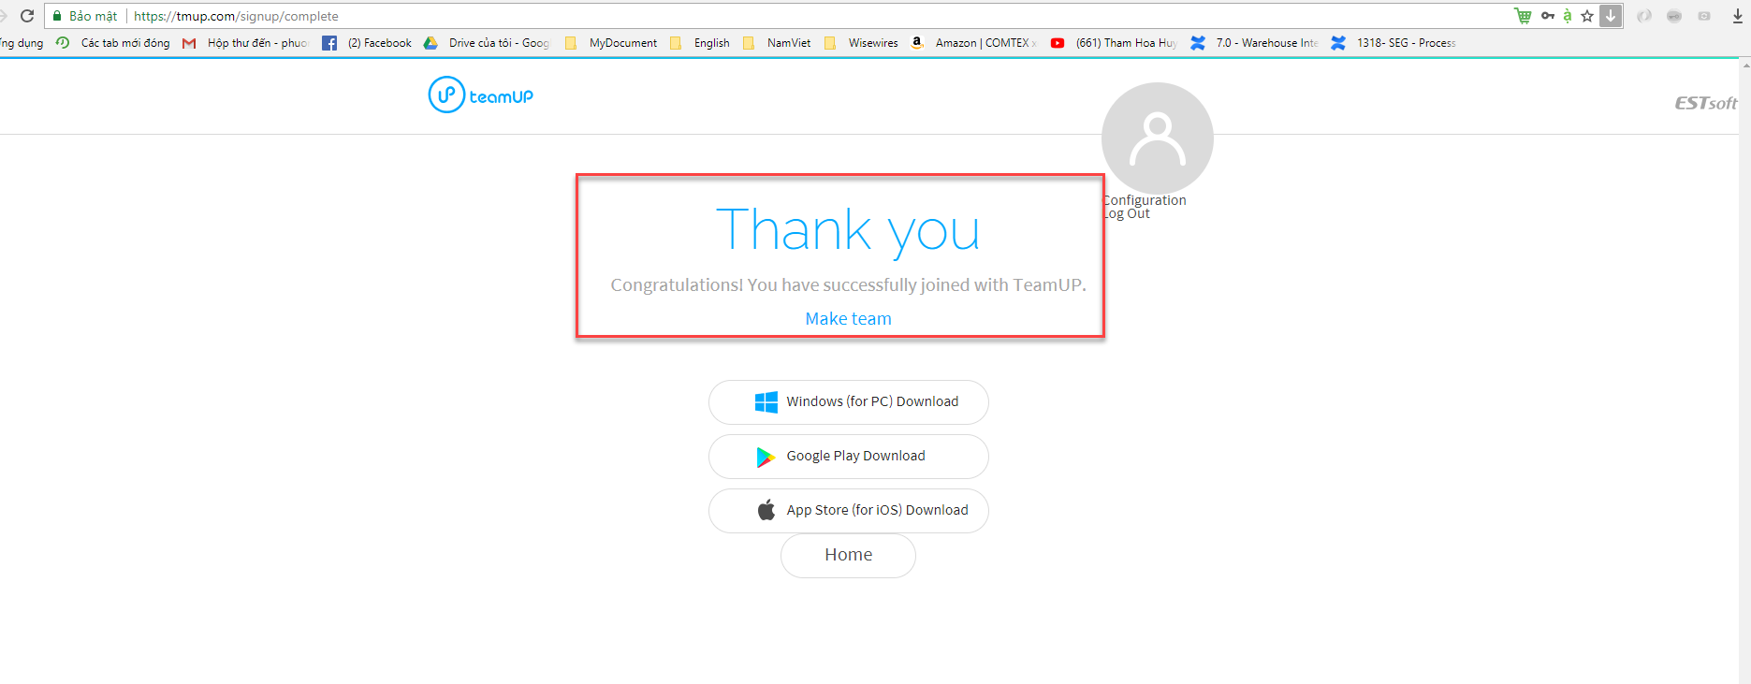

* **Step 7**: Login Team Up again

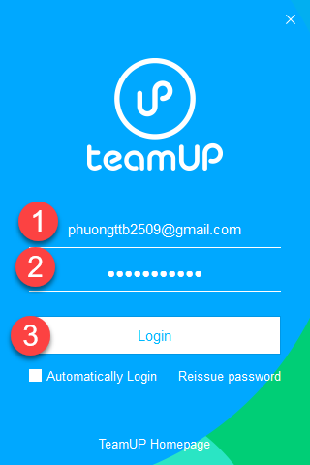

* **Step 8**: There is nothing to do with this screen, just quit the app and wait for the notification from the Instructors.

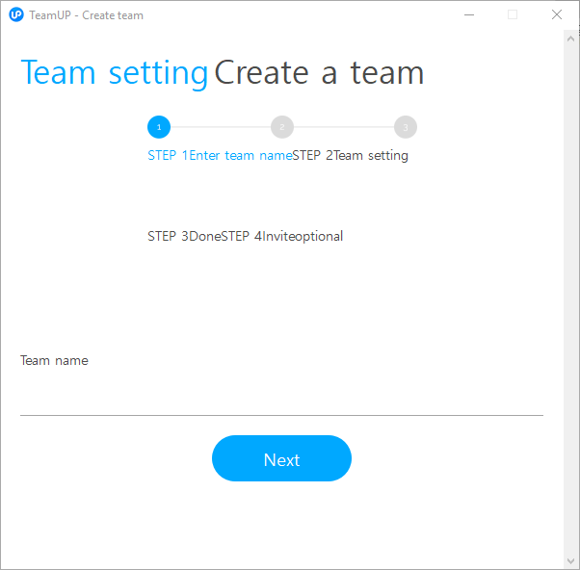

* **Step 9**: Once the Instructors notice, check your Outlook from [noreply@tmup.com](mailto:noreply@tmup.com) and click on “**Accept**” button as image below and you are in!

